SALES

Evaluate the sales plans of DTH providers in India. Particularly focus on TATA SKY & VIDEOCON D2H.

Your assignment should give details on the following:
- Small description about the industry.
- Company profile and organization structures.
- Consumer profile for the segment – both present & targeted.
- Consumer offers & prominent promotional tools used by each organization to boost sales. Mention other DTH players in this section as well like BIG TV & DISH TV.
- Recommendations to increase segments, penetration & sales.

Assignment Instructions

1. The assignment should be a report of words in between 1500-3000.

2. The assignment must have factual data for the last 6 months.

1.DTH Industry overview:
The history of Indian television dates back to the launch of doordarshan, India’s national TV network in 1959. The transmission was in black & white. The 9 th Asian games which were held in 1982 in the country’s capital New Delhi heralded the mark of color TV broadcasting in India. In 1991, Indian economy was liberalized from the License Raj and major initiatives like inviting foreign direct investments, deregulation of domestic business emerged. This lead to the in flux of foreign channels like Star TV and creation of domestic satellite channels like Sun TV and Zee TV. This virtually destroyed the monopoly held by doordarshan. In 1992, the cable TV industry started which lead to revolution. Every city in the India had a complex web of co-axial cables running through the streets with a new breed of entrepreneurs called as cable wallahs or Local Cable Operators(LCO) taking in charge of distribution. The film industry was shocked by this sudden growth and there were even organized protests for calling off the Cable TV industry. There were simply too many cable operators in the country and the channels had a difficult time in getting its returns as the existing system was a non-addressable and the operators could simply give a reduced number of subscribers to amass profit. This lead to the emergency of a new breed of firms called as Multi System Operators (MSO) who had heavy financial muscles to make capital investments. . The MSO industry became highly monopolistic which warrants government participation to ensure competition. Later on, the United Front Government had issued a ban on use of ku band transmission. After a change of government, the ban got lifted finally in 2001 and TRAI issued the guidelines for operating DTH. Country’s first private DTH license was awarded to Dish TV in 2003 which started operations in 2004. Prasar Bharati also started its product DD-Direct+.DTH Digital TV system receives signals directly from satellite through the dish, decodesit with the Set-Top Box and then sends stunningly clear picture and sound to TV which is the business under taken by some companies by observing the rate of growth and scope for business & opportunity in the Indian market which has 120 million viewers of TV.

List of players in the industry
•Doordarshan – (DD-Direct +) of Prasar Bharati comprising of 33 FTA channelsand 12 All India Radio Channels.
•Dish TV of ZEE group.
•Tata Sky joined venture between Tata and Rupert Murdoch’s Sky TV.
•Sun direct of Sun Network.
•BIG TV of Reliance Anil Dhirubhai Ambani group.
•Airtel digital TV of Bharati telemedia
•Videocon d2h of videocon industries

Categorization of players in the industry
Government owned player: DD Direct+.Private players: Dish TV, Tata Sky, Sun direct, Big TV, Airtel digital TV, Videocon d2hBrief profile of players in the industry

Market players:
Today the market shares of various players are as follows

DishTV : 30%
Sun Direct: 25%
Tata Sky: 22%
BIG TV : 13%
Airtel : 8%
D2H : 2%

2.OMPANY PROFILE:
TATA SKY:

TYPE | Joint venture group b/w tata group (80% stake) & star tv (20% stake)
FOUNDED | 2004
HEADQUARTER | Kirloskar Business Park, Bangalore, India
INDUSTRY | DTH pay tv
PRODUCT | Direct broadcast satellite
SLOGAN | Iskonlga dala to life jingalala
WEBSITE | www.tatasky.com

Tata Sky, an 80:20 joint venture between Tata Sons and the Star group, provides satellite television services to Indian viewers. The company was incorporated in 2004 and offers a range of media and entertainment options to customers.
VEDIOCON D2H:
Company profile:
Type | Subsidiary of Videocon
Industry | Satellite television
Founded | 2009
Headquarters | Mumbai, india
Area served | India
Product | Direct broadcast satellite, pay-per-view, pay television
Parent | Vediocaon company
wabsite | Vedeocond2h.com

Videocon d2h, the DTH arm of Videocon group is the fastest growing DTH service provider in India. Videocon d2h has 292 Channels and Services on its platform. It uses the revolutionary MPEG – 4 DVBS -2 technology. It has many exciting features like Multiple Tickers, 12 PIP Mosaic, 22 Active Music Audio Video Channels, d2h movies. It carries the highest number of sports channels and all GEC channels on its platform. It also has the highest number of regional language channels in Kannada, Bengali, Marathi, Oriya and North East.

3.DEPARTMENT HIERARCHY:
Vediocaon D2H:
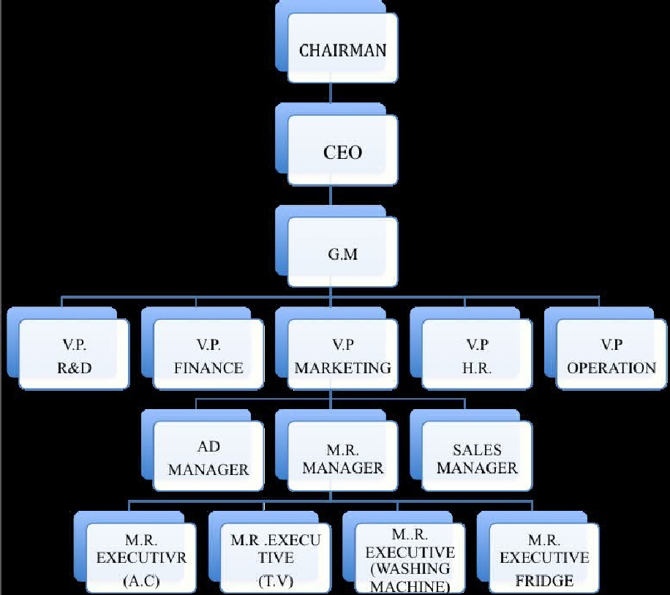

Tata sky:

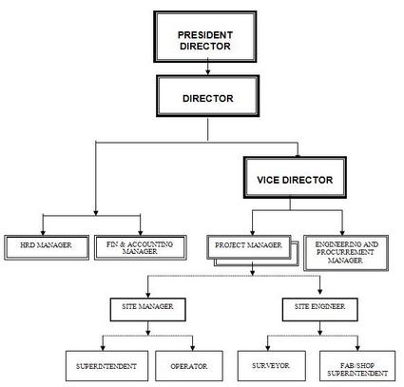

3.Customer profile and segmentation :

Consumer profile for TATA SKY:
- 54% of the respondents belong to the age group of 22-30
- 28% belongs to 30-40 years age group
- and rest above 40 years of age..
- If we compare the age group of the people we will see that people in the age group of 22-30 are the end u\ser of the TATA SKY.
Consumer profile for Videocon D2h:
- So Videocon has also targeted the age group of 20-30 years and their second age group target the house wives who are the major viewers of television.
- In future they will be targeting the rest of the class as they are adding cartoon channels, internet facilities, games etc.

4. TATA SKY OFFERS AND PROMOTIONS:

Tata Sky DTH service redefines your TV viewing experience by offering new age interactive services with DVD quality picture and CD quality sound. Apart from the genre-based packages, you can choose individual channels and make your own pack. You can also mix-n-match by adding individual channels to your existing genre-based packages.

Tata Sky Tariff Plan Highlights

South Economy Pack:
Enjoy up to 61 channels with two FREE Regional Packs at Rs 150 per month. You can also pay Rs 850 semi-annually or Rs 1,650 per annum.

Economy Pack:
It’s a true economic plan that gives you 74 channels and two FREE Regional Packs at only Rs 160 per month. You can also choose to pay Rs 900 semi-annually or Rs 1,760 per annum.

Supreme Pack:
It includes Economy Pack + Hindi Movies Pack + Music Pack + Knowledge Pack. This combo pack comes for Rs 240 per month and can be paid for Rs 1,250 semi-annually or Rs 2,420 per annum.

Grand Pack:
This pack comes with Supreme Pack + English News Pack + English Movies Pack + English Entertainment Pack + Kids Pack. You can enjoy up to 134 channels at Rs 380 per month. You can save few bucks by paying Rs 2,180 semi-annually or Rs 4,180 per annum.

State Pack:
It exclusively includes 86 Regional Channels which can be enjoyed for Rs. 185 per month. You can also pay Rs. 1,030 Semi-annually or Rs. 2, 035 per annum

Optional Packs

Packs name Price/month
Hindi movies Rs 35 pm
Music Rs 20 pm
Kids Rs 45 pm
English News Rs 20 pm
Sports 1 Rs 65 pm
Sports 2 Rs 40 pm
Sports 3 Rs 20 pm
Fun Learning Rs 40 pm
Active English Rs 30 pm
Knowledge Rs 35 pm
Topper Rs 45 pm
English Movies Rs 45 pm
English Entertainment Rs 35 pm
Ten Cricket Rs 30 pm
Annual Sport Gold Rs 365 pa
India Cricket Rs 365 pa
Active cooking Rs 10 pm
HD GOLD Rs 40 pm

Tata Sky provides wide array of offers and discounts for its consumers:

It has attractive plans for new as well as existing customers. It provides diverse type of offers which cater to the requirements of various tastes of consumers. Bundled special offers of Tata Sky are targeted at new consumers and provide good discounts on few selected Popular packs for a period of 3 or 5 Months.

Bundled Special Offers of Tata Sky are mentioned below.

Rs 1590 Special Offer:
It costs RS 1590 and includes the following package.
· Tata Sky set top box
· Installation
· 5 months South Sports Pack (82 Channels and 3 interactive services)

Rs 1625 Special Offer:
It costs RS 1625 and includes the following package.
· Tata Sky set top box
· Installation
· 3 months State Pack (89 Channels and 3 interactive services)

Rs 1725 Special Offer:
It costs RS 1725 and includes the following package.
· Tata Sky set top box
· Installation
· 3 months Supreme Sports Pack (89 Channels and 3 interactive services)

VEDIOCON D2H PLANS AND OFFERS:

TARIFF PLANS:

North, West and East
Packages | 24 months Price | 11 months Price | 6 months Price | 3 months price
New Gold | 4200 | 1925 | 1050 | 525
New Gold Sports | 5680 | 2600 | 1420 | 710
New Diamond | 7000 | 3200 | 1750 | 875
Platinum | 9000 | 4125 | 2250 | 1125
Platinum HD | 10580 | 4850 | 2600 | 1320

South
Packages | 24 months Price | 11 months Price | 6 months Price | 3 months price
South Silver Pack | 3600 | 1650 | 900 | 450
South Silver Sports Pack | 4800 | 2200 | 1200 | 600
New South Gold | 4200 | 1925 | 1050 | 525
New South  Gold Sports | 5680 | 2600 | 1420 | 710
New South Diamond | 7000 | 3200 | 1750 | 875
South Platinum | 9000 | 4125 | 2250 | 1125
South  Platinum HD | 10580 | 4850 | 2600 | 1320

The Videocon D2H Satellite box sports following features:

- UNIVERSAL REMOTE – Can Operate TV as well as Satellite Box.
- Mosaic (12 PIP) – Genre wise
- Favourites
- Multilingual Channel Guide
- Preview Screen (Full Guide)
- Info Bar of the running program
- Tickers
- Watch while Play
- Active Services –Direct Activ(Darshan, State, DD & Finance) /Direct Games / Direct Puzzle
Videocon D2H Packages

Videocon d2h presents you with a variety of channel packages. Subscribe to one of the Base packages and then choose any or all the Add-On packages you want. Now, pay only for what you want to watch.
There are two packages options in Videocon D2H digital TV service :

- Gold Pack
- Diomond Pack
- Gold Sports pack
Videocon D2H Gold Pack Channel List
Rs.136/month,177 Channels & services

1.GENERAL ENTERTAINMENT
- Star one,Utv Bindass,colors,sony,ndtv,imagine,sab,sahara one
- Star Utsav,DD National,9x,Star Plus,Zee Tv,Firangi
2.HINDI MOVIES:
Set Max,Zee Cinema,Star Gold,Filmy,Utv Action Utv Movies

3.ENGLISH MOVIES:
MGM

4.SPORTS:
DD Sports

5.KIDS:
Cartoon Network,Hungama,Disney XD

6.MUSIC:
9x M,Channel V,Music India,Zing

7.HINDI NEWS
Star News,NDTV India,India Tv,zee news,ibn7,DD Rajyasabha,DD News,CNBC Awaaz
Zee Business,aajtak,DD Loksabha,Sudarshan News,aajtak,Day & Night News

8.INFOTAINMENT & LIFESTYLE
Discovery,NGC,Animal Planet,History,DD Bharati,Care World,zoom,ftv,aajtak,E 24

9.RELIGIOUS:
Mh1 Shraddha,Aastha,Sanskar,Paras

10.REGIONAL
Punjabi:Ptc Punjabi,Zee Punjabi,Etc Punjabi,Ptc News,Mh1 Music,DD Punjabi ,PTC Chakde,
Bhojpuri:Mahua,Sangeet Bhojpuri,
Tamil:Star Vijay,Kalaignar,Jaya Max,Siripoli,Isia Aruvi,Jaya Max,Jaya Plus,Seithigal
Telugu:Etv,Zee Telugu,Etv2,Tv9 Telugu,Ntv
Kannada:Etv Kannada,Tv 9 Karnataka,Suvarna News,Suvarna,Kasturi,DD9 Chandana ,Suvarna news 24X7
Malayalam:kairali,amrita,dd malayalam,indiavision,shalom,Asianet,Jai Hind,
Marathi:Zee Marathi,Star Pravah,Zee 24 Taas,Mi Marathi,Saam Tv,Etv Marathi,Zee Talkies,Star Majha,Ibn Lokmat,DD10 Sahyadri
Bengali:Zee Bangla,Etv Bangla,Star Aananda,Aakash Bangla,Star Jalsha,24 Ghanta Tv,Rupashi Bangla,DD Bangla,Sangeet Bangala,News Time,Sony Aath
Gujarati:Etv Gujarati,Tv9 Gujarati
DD girnar:Etv Gujarati,Tv9 Gujarati,DD girnar,
Oriya:Etv Oriya,Naxtara News,Otv,DD Oriya,Tarang,Tarang Music
Urdu:Etv Urdu,DD Urdu,
More:Nepal 1,ETV Rajasthan,Ne Tv,Rang, DY 365,News Live

Videocon D2H Diamond Pack channel list

Rs.265/month,243 channels & services . NEW DIAMOND PACK includes the NEW GOLD PACK plus following channels :

ENGLISH ENTERTAINMENT:star world

ENGLISH MOVIES:Pix,Zee Studio,HBO,Utv World Movies,Warner Brother,star movies

SPORTS: Neo Cricket,Neo Sports,Star Cricket,ESPN,Star Cricket,Zee Sports,Ten Sports

KIDS:Disney Channel,Nick,Pogo,Animax

ENGLISH NEWS:Times Now,NDTV 24*7,CNN IBN,Headlines Today,CNN,CNBC TV18,Bloomberg Utv,NDTV Profit,ET Now,BBC

MUSIC:mtv,vh1

INFOTAINMENT & LIFESTYLE:NDTV Goodtimes,TLC,AXN,Zee Café

REGIONAL
Tamil:Raj TV,Vasanth TV
Telugu:Saksh TV,Sitara,TV5
Kannada:Zee Kannada,Manorama News,Asianet,Asianet Plus

Videocon D2H New Gold SPORTS Package Channel List
Includes the NEW GOLD PACK plus the following channels

Neo Cricket,
Neo Sports,
Star Cricket,
ESPN,
Star Cricket,
Zee Sports,
Ten Sports

Videocon D2H Add-ons Packages

SPORTS STARTER – Rs.30 per month
Zee Sports,Ten Sports

NEO – Rs.35 per month
Neo Cricket,Neo Sports

SPORTS MEGA – Rs.60 per month
ESPN,Star Cricket,Star Sports

TAMIL WORLD – Rs.35 per month
Sun Tv,Sun News,Sun Music,Ktv,Chutti Tv,Adtihya,Raj TV,Vasanth TV

TELUGU WORLD – Rs.30 per month
Maa Telugu,Gemini Tv,Gemini Music,Teja Tv,Gemini News,Sakshi TV,Sitara,TV5,Navvulu TV

KANNADA WORLD – Rs.30 per month
U2,Udaya Movies,Udaya Varthegalu,Udaya Tv,Zee Kannada,Ushe TV

MALAYALAM WORLD – Rs.30 per month
Surya Tv,Asianet,Asianet Plus,Manorama News,Kiran Tv

ENGLISH ENTERTAINMENT – Rs.50 per month
Star Movies,Pix,HBO,Zee Studio,Utv World Movies,Warner Brother,Star World

KIDS ZONE – Rs.25 per month
Disney Chhanel,Nick,Pogo,Animax

NEWS WORLD – Rs.10 per month
BBC World

ENGLISH NEWS – Rs.30 per month
Times Now,NDTV 24×7,CNN IBN,Headlines Today,CNN
MUSIC MANTRA – Rs.20 per month
Mtv,Vh1

INFOSTYLE – Rs.30 per month
NDTV Goodtimes,AXN,TLC,Zee Café

BUSINESS NEWS – Rs.25 per month
CNBC TV18,NDTV Profit,ET Now,Bloomberg Utv

BIG TV
Pricing & package:
Reliance BIG TV has again shown here their great marketing skills. Their normal subscription rates are lower as compared with the other DTH giants. An amount of 1400 INR are basically for people going for normal subscriptions, but for the buyers of LG television the subscription further goes down to 700 INR. Now that’s a big offer! Besides the channels packages here are compiled with Hollywood and Bollywood movies, along with sports and science channels. They also have learning channels and regional channels.

Promotional strategy:
DTH (Direct to home) services, in which with the help of set top box and dish, the signals from satellites are received, thus giving better and brighter pictures and great audio clarity. The DTH services, hence offer by Reliance are named as BIG TV. This revolution of television world is slowing pulling many players and this is really steaming the market. Since all these companies are taking film star as their brand ambassadors, Reliance is also trying to hook some actor to support their promotional strategy. Apart from the celebrity game, Reliance has always tried to give its users, something more than usual and the same strategy is seem to be working here as well, with the extra number of channels.

Dish tv

Dish tv provides you with a range of price offers & schemes, giving you the power to choose from a basic entertainment package upto 180 digital channels. It is the only platform in India, which allows you to choose the best of television entertainment specific to your needs and pocket.

Recommendations:

Videocon d2h:

- There should be exchange offer .
- D2H & BIG TV provide the free news channels for the student like current news, share market, game, and world news so mention it.
- Form an efficient research and development team in order to improve quality and add technical features in the products.
- Create an effective advertisement with an influential punch line.
- Improve products finishing, packing and service to the customers.
- Organize contests, events, games to promote company’s brand image.
- Reduce manufacturing, sales and distribution and other indirect cost and invest on advertisement R&D and other sales promotion tools.
- Attract customers by exchange offer, discount offer, cash back offer and face gift offer on the festival occasions.
- Establish a cordial relationship with dealers and offer a good commission margins for promoting our products.
- Keep a hawk eye on the competitors and act according to their sales and marketing strategy.
Tata sky:
As Tata Sky Plus is targeting a niche market, it should make its products like provogue more widely available in the market.
• The availability of DTH is still lacking in the rural.
• Need to drive more offers and attractive plans.
• Should even more try to work it on for lower middle class people?
• Should introduce schemes.
• Much stronger customer service.
• Easy accessibility of recharge coupons.
• Should categories their customers.

Market penetration:

1) Increase awareness: Since there is lack in communication channel, it should be tackled with care and dealers should be constantly made aware about the offers and new plans through meetings with company executives at regular intervals.
2) Improve processes and techniques: In order to make recharge or activation process more transparent and user friendly, the EPRS technology needs to be upgraded consistently.
3) Give more value added services: Since Tata sky and Airtel have clear edge over value added services like free installation DTH needs to mend itsstrategy to face these competition. One way of doing this would be to offer at least the same service as these two competitors are trying to eat the market share.
4) Improvement in after Sales Services: Arrange: proper training for customer care executives as Dish TV lacks proper after sale service against the service provided by Tata Sky & other brands.
5) Standardized the price plans and avoid frequency changing: Frequent changes in price and offers is proving no good for Dish TV as it is in way frustrates the customers with changes in offers without being informed about it.
6) Voucher Availability: Make proper channel of Distribution of voucher. As sometimes it becomes hectic for any consumer to find a voucher recharge dealer.
7) Visibility: Danglers create more impact on customer mind, it always visible and promote offer and help to recall brand resonance

